RIPHAH INTERNATIONAL UNIVERSITY



NAME | ALIZA SHAHID
SAP ID | 56264
PROGRAMME | BSCS 3RD SEMESTER
COURSE | WEB DEVELOPMENT
LAB | 01
SUBMITTED TO | MAM NAYAB KHALID

LOGIN PAGE

Code:

<!DOCTYPE html>
<html>
<head>
<title>login page</title>
</head>
<body>
<div class="main">

<form>
<h3>LOGIN FORM</h3>

<label>Email:</label>
<br>
<input type="text" placeholder="username" required>
<br>
<label>Password:</label>
<br>
<input type="password" placeholder="Enter your password"

</form>
<br>
<button>login</button>

</div>

</body>
</html>

Website:

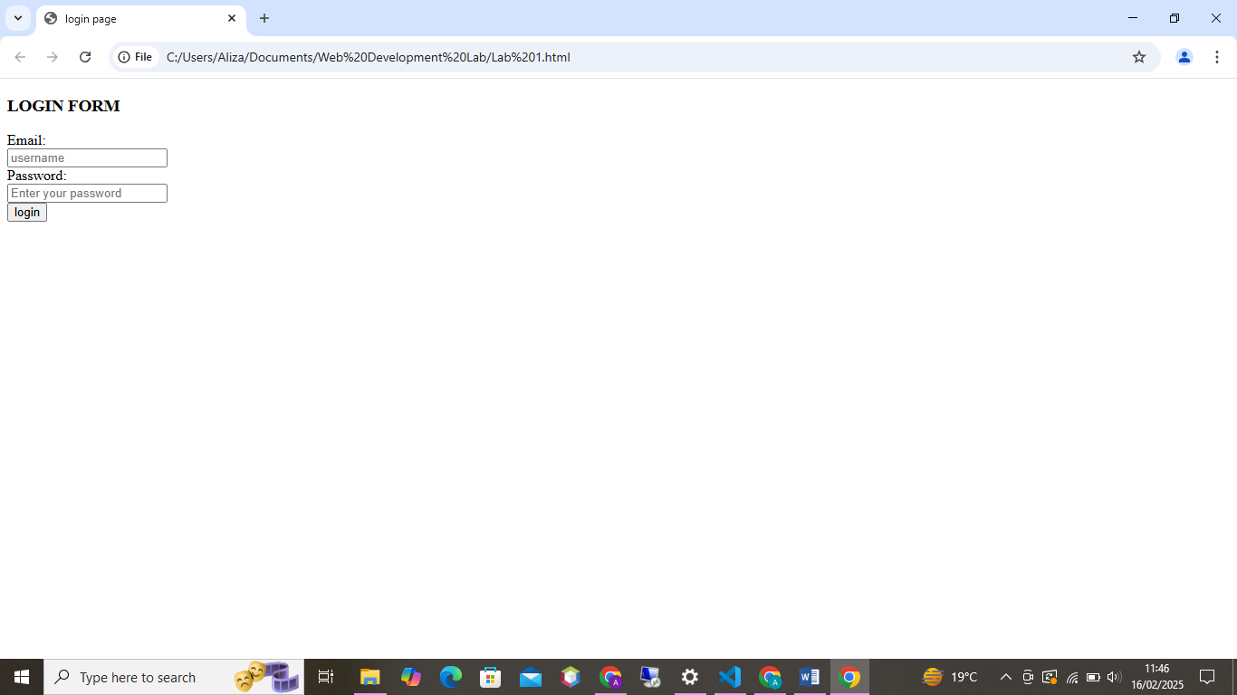

THE END!!

